MLTA-PAC
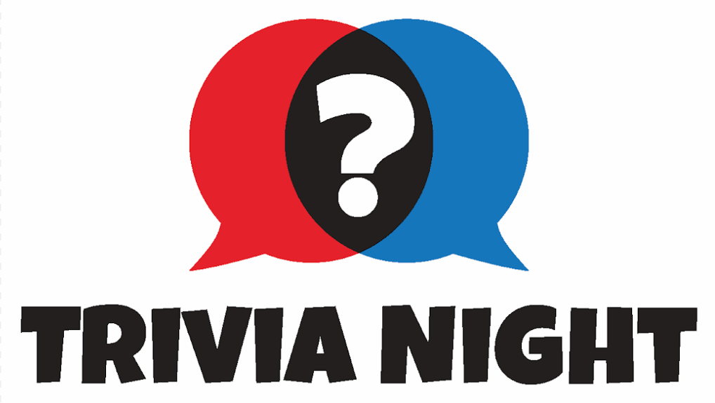

If you are attending the MLTA Summer Convention at Grand Traverse Resort, the MLTA-PAC Committee would like to invite you to join us for Trivia Night immediately following the Welcome Reception and Dinner on July 14th.
RULES:
- Team Entry Fee—Minimum $100 contribution to the MLTA-PAC.
- Teams should be 4-6 people. Teams are encouraged to form as soon as possible but you can also form a team at the convention.
- Teams will be rewarded for raising funds for the MLTA-PAC beyond the minimum of $100. Teams will be rewarded a bonus card for each $250 they raise for the MLTA-PAC. These cards can be used to increase the team’s score by answering bonus questions during the trivia night competition.
- Teams are encouraged to design team shirts/uniforms.
- The questions will be from five different categories with scoring to be tabulated by a professional Trivia Night Host.
- Some questions may be title related.
AWARDS:
- Best Team Shirt/Costume Award
- Top Fundraising Team Award
- Trivia Night Champion Team Award
HOW DO WE ENTER?
Email your team roster to Tim McDonnell at tmcdonnell@oldrepublictitle.com and make your minimum $100 team contribution at the https://www.milta.org/about/pac/ or mail a check made payable to “MLTA-PAC” to the MLTA Office Attn: MLTA PAC Trivia Night. NOTE: The MLTA-PAC cannot accept corporate contributions, so all contributions must come from an individual. THANK YOU IN ADVANCE FOR SUPPORTING THE PAC!

